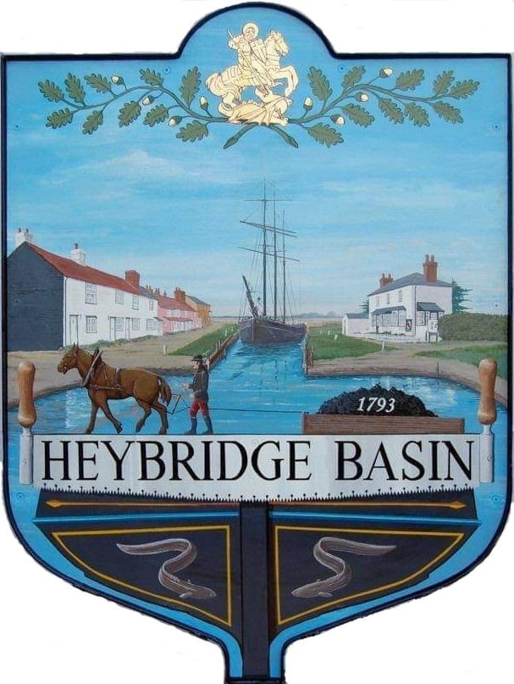

HEYBRIDGE BASIN PARISH COUNCIL

Minutes of the Annual Statutory meeting of Heybridge Basin Parish Council held on Monday 20th May 2024 at 06:30pm, at The Lock Tearoom.

PRESENT

In the Chair: M. Hodges (Chair) Absent: 0

Councillors: R. Bryson (Vice Chair) Apologies: 2
C. Swann
M. Hobden Public: 14
J. Sjollema
Officers: G. Lake – Clerk

It was noted that this meeting was being recorded by the Clerk.

24/001 Election of Chair
To elect the Chair for the year 2024-25 and Chair to sign Declaration of Acceptance of Office.
It was resolved to elect Cllr Hodges as Chair of the Parish Council for 2024/25
Proposed: Cllr Bryson
Seconded: Cllr Sjollema
All agreed.
Cllr Hodges signed the Declaration in front of the Council and Clerk.

24/002 Election of Vice Chair
To elect the Vice Chair for the year 2024-25.
It was resolved to elect Cllr Bryson as Vice Chair of the Parish Council for 2024/2025
Proposed: Cllr Swann
Seconded: Cllr Hobden
All agreed.

24/003 To note apologies for absence.
Cllrs Edmond and Howat

The Chair announced that Item 17 – Planning applications would be moved to follow Item 9 – Public Forum as per Standing Order 2a.

24/004 To receive Declarations of Interest in accordance with the Council’s Code of Conduct and with section 106 of the Local Government Finance Act 1992.
Cllr Hobden – Non-Pecuniary – HBSA, Basin Oars and HB River care and Cllr Swann - Non-Pecuniary - Owner of Tearoom building.

24/005 General Power of Competence
To confirm the Councils eligibility and adopt the General Power of Competence
It was noted that the Clerk gained the Certificate in Local Council Administration (CiLCA) on 25th March 2024.
It was noted that the Council fulfils all of the eligibility criteria for the General Power of Competence.
It was resolved to formally adopt the General Power of Competence.

24/006 To sign as a correct record the minutes of the full council meeting held on 23rd April 2024.
The Minutes as previously circulated were agreed as a correct record.

24/007 To sign as a correct record the minutes of the extraordinary meeting held on 29th April 2024.
The Minutes as previously circulated were agreed as a correct record.

24/008 To receive a report from the District and County Councillors for the area on any matters of interest.
A report was received from the District Councillors and County Councillor.

24/009 Public Forum
No members of public wanted to speak on anything not related to a planning application.

24/010 Planning Applications
- To consider any planning applications received after the publication of the agenda and to agree the action to be taken.

24/00183/FUL – Leanna House, Lock Hill – Part demolition existing workshop; two storey side extension, raising of roof and conversion to residential dwelling with ground floor garage below.
It was resolved that the Council would recommend the refusal of planning permission for this application due to the loss of privacy/overlooking neighbouring properties, materials in the roof and height.

3 members of the public left.

24/00349/LDP – The Old School House, 92 Basin Road – Claim for lawful development certificate for proposed installation of 12 solar panels.
It was resolved that the Council would recommend supporting the installation of solar panels as the drawings show that the panels will not be facing a public road which complies with the rules of a Conservation Area.

Cllr Hodges left the room.

24/00408/HOUSE – 25 The Colliers – Extension to front porch including canopy projection and rooflights. Single storey lean-to front extension.
It was resolved that the Council would recommend the granting of planning permission for this application.

Cllr Hodges returned.

24/011 Schedule of Meetings 2024/2025
- To agree on the dates of Full Parish Council meetings up to and including the next annual meeting of the Parish Council.
The proposed Schedule of Meetings for 2024/2025 were approved.

4 members of the public left.

24/012 Unmetered Electricity Supply
  - To receive an update from the Clerk and agree any action to be taken.
An update was received, and quotes were circulated. It was resolved to accept the quote for 1 year and to seek quotes from other companies for the next renewal.

24/013 Finance.
- To approve
- Payment requests for April/May 2024
The Payment requests as previously circulated were approved with the condition of removing the second payment request from Camway due to incorrect invoicing terms and to allow the Council to assess the work.
- Receipts for April/May 2024
It was noted that the Precept for the year was received on 7th May. The receipts as previously circulated were approved.
- To consider renewal of membership with the Maldon & Heybridge Heritage Harbour Association at a cost of £20.
It was resolved to renew the membership.
- The continued use of direct debit for the payment of the following:
Staff pension, car park business rates, Unmetered power supply, Green Recycling and ICO.
It was resolved that to continue the use of direct debit for the above items.
- To reaffirm bank account signatories and review if there is a need for any amendments.
The bank account signatories were reaffirmed with no amendments.
- To appoint one member as Bank Verifier.
It was resolved that Cllr Sjollema would be appointed as Bank Verifier.

24/014 Appointments of Committees, Working Groups and Representatives
- To consider the continuation of the Daisy Meadow Car Park Working Group or setting up a Sub Committee and appointing members to serve (3 minimum).
It was resolved to continue with the Daisy Meadow Car Park Working Group and would consist of Cllrs Hodges, Bryson, Hobden, Swann Sjollema and the Clerk.
- To confirm the continuation of Delegated Authority within Daisy Meadow Car Park to the Clerk.
It was resolved for the Clerk to continue to have delegated authority.
- To appoint members to serve on the Personnel Committee (3 minimum) and to approve the Personnel Committee Terms of Reference.
It was resolved to appoint Cllrs Hodges, Bryson and Sjollema as members of the Personnel Committee. Terms of reference to be reviewed at next meeting.
- To consider the membership of the On-Street Parking Working Group.
It was resolved that the On-Street Parking WG would consist of Cllrs Hodges, Bryson, Swann and Sjollema.
- To consider the membership of the Village Design Statement Working Group.
It was resolved that the Village Design Statement WG would consist of Cllrs Howat and Sjollema as well as the parishioners that wish to be involved.
- Any other committee or Working Group as considered appropriate.
There were no suggestions.
- To appointment one representative each to the following bodies:
- Maldon and Heybridge Heritage Harbour Association
It was resolved for Cllr Edmond to be lead representative.
- Chelmer Canal Trust
It was resolved for Cllr Hobden to be lead representative.
- 20’s Plenty for Essex
It was resolved for Cllr Sjollema to be lead representative.
- Any other representative as considered appropriate.
Public Transport Group - It was resolved for Cllr Sjollema to be lead representative.

24/015 Policies and Procedures
  - To confirm the following policies reviewed by the Clerk with no amendments:
  - Freedom of Information
  - Publication Scheme
  - Code of Conduct
  - Standing Orders
It was resolved to approve the amended policies with no amendments.
  - To review and adopt the following:
- Financial Regulations
It was resolved to approve the current Financial Regulations in order to review the new NALC 2024 Model Financial Regulations.
- Reserves Policy
- Investment Policy
- Memorial Policy and Essex Waterways License Agreement
It was resolved to approve the above policies and for the Clerk to create an application form for the Memorial Policy and send the signed License Agreement to Essex Waterways.

24/016 Action Plan
- To review the Action Plan and agree any action to be taken.
It was resolved to approve the Action Plan and review in 3 months.

24/017 DMCP
- To receive an update from the Working Group and agree any action to be taken.
An updated was received. It was resolved to instruct Haydn Evans to attend site to ensure the design was followed at a cost of up to £1000.00 plus VAT.

Camway advised that they were unable to change the fencing as requested by the Council on 18th April, as the original order of fencing had already been ordered. Members noted that Camway advised the fencing had not been ordered on 18th April, which allowed the Council to request amendments. There would be an additional cost to change the fencing height and style at this stage. It was resolved to instruct Camway to proceed with the original fencing at a cost of £ 5,273.85 plus VAT.

It was resolved for the Working Group to review the current grounds maintenance schedule.

It was resolved for HRS Marine Services to dig the holes for the Silver Birches at a cost of £50.00 Cllr Swann abstained from the vote.

24/018 D-Day 80
  - To receive an update from the Working Group and agree any action to be taken.
An update was received. It was resolved for the Working Group to approve the Risk Assessment at their next meeting. It was resolved to purchase the following:
- One D-Day 80 flag from the RBLI Shop at a cost of £19.99 plus £3.99 shipping.
- £20 voucher from The Jolly Sailor.
- 100 Milk Chocolate Coins at a cost of £16.50.
- 40 D-Day Coins at a cost of £100.00

24/019 Correspondence
- To note correspondence received and consider any actions to be taken.
Correspondence was noted and responses were agreed. It was resolved to purchase an afternoon tea for two voucher from The Lock Tearoom at a cost of up to £50.00 to donate to Row4aReason.

24/020 Newsletter
- To consider items to be included in the next Parish Council Newsletter and delegate articles to Councillors.
- Council Formation
- Speed Watch
- Nature Competition
- Defibrillators
- DMCP Road
- D-Day Event

24/021 Clerk’s Report
- Register of Interests – Members were reminded that their registers of interests needed reviewing at least annually.
- Councillor Training – It was noted that it is advisable for all members of the Council to have attended Councillor Training, and that currently 3 members of the Council had attended.
- Website Accessibility Compliance – Clerk had attended Scribe Training regarding website accessibility compliance delivered by a company called Aubergine. Clerk advised that the current website did not comply with the current regulations and are due to update in October 2024. Clerk advised that the Council consider this at the next budget review.

24/022 Local Issues
- To note any items of inclusion on the agenda for the next meeting of the Parish Council.
- Reserves

24/023 Pursuant to section 1(2) of the Public Bodies (Admission to Meetings) Act 1960 it is resolved that, in view of the confidential nature of the business about to be transacted, it is advisable in the public interest that the press and the public be excluded, and they are instructed to withdraw.

Members of the public left.

24/024 Timber Yard
- To discuss the proposal received from Govey Homes Ltd and agree any action to be taken.
It was resolved to that the Council would consider the Section 106 proposal subject to feedback from the residents. It was resolved to create a questionnaire to be distributed with the Newsletter.

It was resolved to extend the meeting until all items had been discussed.

24/025 Daisy Meadow Car Park
- To discuss correspondence received and agree any action to be taken.
The correspondence was noted. It was resolved to instruct Petro Designs Ltd to undertake a Condition Survey at Rohan House at a cost of £800.00 plus VAT.

There being no further business the meeting closed at 09:05pm
Provisional Date of the next Council Meeting Tuesday 18th June 2024

Clerk Contact details: clerk@heybridgebasinpc.org.uk
Website: www.heybridgebasin-pc.gov.uk

